Dis-Can-BC-Haida-Bear Plaque

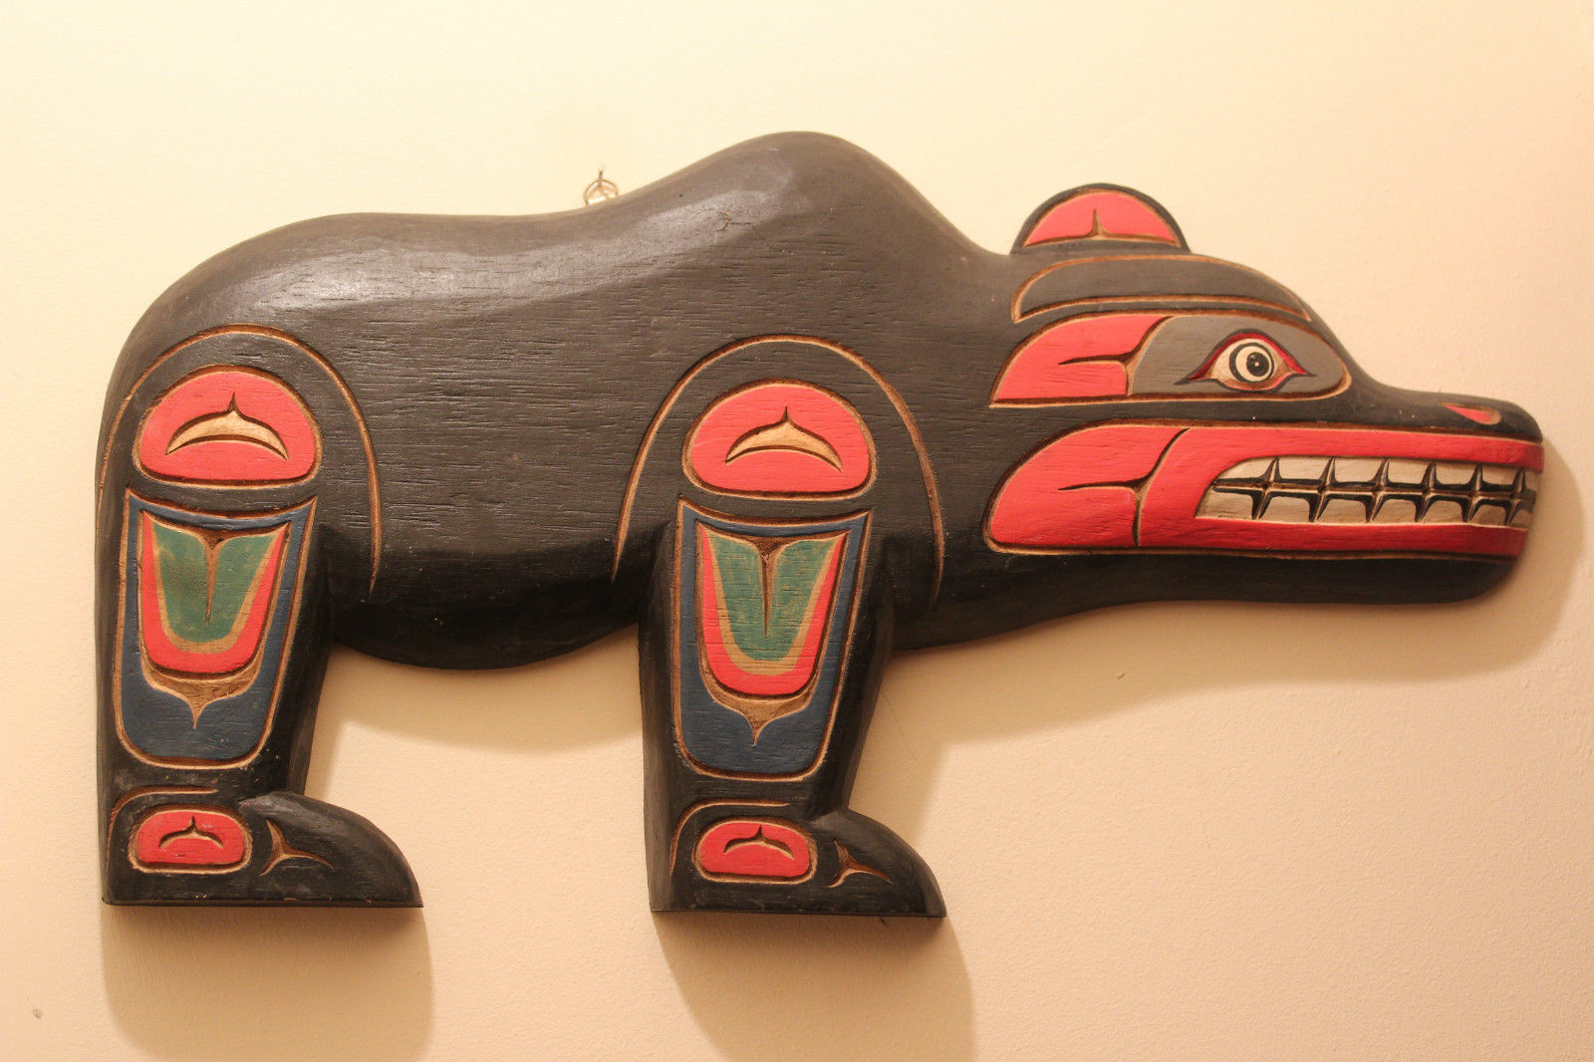 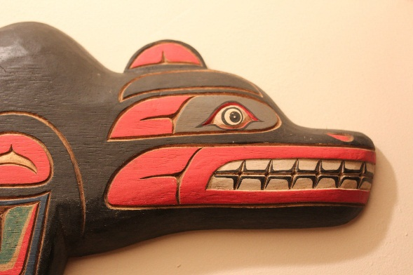 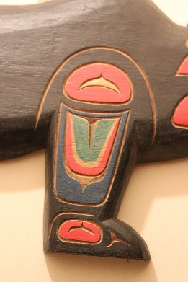 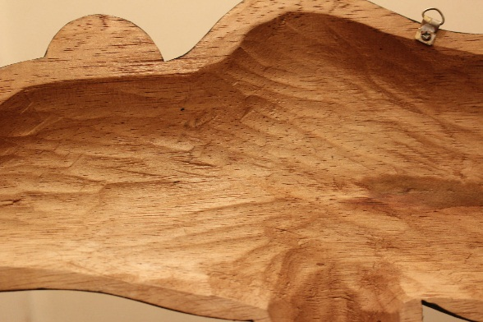

**Formal Label: Haida Bear Plaque**

**Accession Number:**

**LC Classification:** E99.H2

**Date or Time Horizon:**

**Geographical Area:** British Columbia

**Cultural Affiliation:** Haida

**Medium:** Cedat Wood

**Dimensions:   
Weight:**

**Provenance:** Cojomolo, 152 halifax road todmorden, OL14 5RE, West Yorkshire, UK

**Condition:** Museum quali**ty.**

**Discussion:** This plaque is ofthe Bear God of the Haida of British Columbia, Kaiti. He took a tribal woman as his wife, and she became a bear spirit herself. This story of a human’s transformation into a bear spirit is a story of shamanic conversion. The origins of the bear myth and the essence of shamanic conversion of a human into a bear spirit is found in European Paleolithic cave art where negative hand prints were stenciled on cave walls by blowing a pigment over the hand of the shaman. Subsequently, these negative prints were slashed by the claws of a cave bear, symbolically linking the shaman with the bear. Among the earliest human altars are those of cave bear skulls set on rock pedestals deep inside the great caves, as though paying homage to a revered animal presence. This plaque is intended to convey the essence of the bear spirit of Kaiti by presenting the Haida symbols of

1. strength in the shoulders ,
2. acuteness of hearing 
3. sight , and
4. speed of travel in the feet  of the bear.

**References:**

Rockwell, David. 1991. *Giving Voice To Bear*. Toronto, Ontario: Roberts Rinehart.

Shepard, Paul and Barry Sanders. 1985. *The Sacred Paw.* New York, NY: Arkana.

Wright, Robin K. 2001. *Northern Haida master carvers*. Seattle, WA: University of Washington Press.